Internet of Things --- Lab 1 Exercise 1

a) Control LED brightness **with** a micro controller

Code used :

int led = 3;

int brightness = 0;

void setup() {

// put your setup code here, to run once:

pinMode(led, OUTPUT);

}

void loop() {

// put your main code here, to run repeatedly:

analogWrite(led,brightness);

delay(3);

brightness++;

}

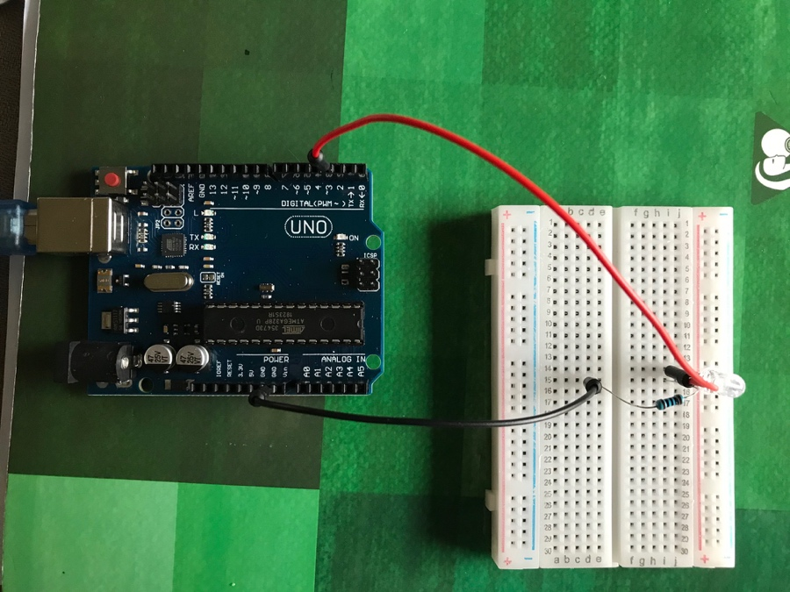 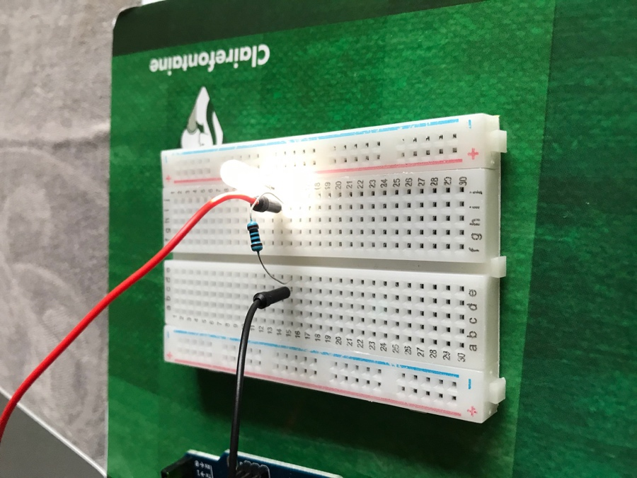

b) Control LED brightness **without** a micro controller

We used an assembly seen in Lab 1

Code used :

Lesson 4 : Analog Input

/*

Analog Input

Demonstrates analog input by reading an analog sensor on analog pin 0 and

turning on and off a light emitting diode(LED) connected to digital pin 13.

The amount of time the LED will be on and off depends on the value obtained

by analogRead().

The circuit:

- potentiometer

center pin of the potentiometer to the analog input 0

one side pin (either one) to ground

the other side pin to +5V

- LED

anode (long leg) attached to digital output 13

cathode (short leg) attached to ground

- Note: because most Arduinos have a built-in LED attached to pin 13 on the

board, the LED is optional.

created by David Cuartielles

modified 30 Aug 2011

By Tom Igoe

This example code is in the public domain.

http://www.arduino.cc/en/Tutorial/AnalogInput

*/

int sensorPin = A0; // select the input pin for the potentiometer

int ledPin = 13; // select the pin for the LED

int sensorValue = 0; // variable to store the value coming from the sensor

void setup() {

// declare the ledPin as an OUTPUT:

pinMode(ledPin, OUTPUT);

}

void loop() {

// read the value from the sensor:

sensorValue = analogRead(sensorPin);

// turn the ledPin on

digitalWrite(ledPin, HIGH);

// stop the program for <sensorValue> milliseconds:

delay(sensorValue);

// turn the ledPin off:

digitalWrite(ledPin, LOW);

// stop the program for for <sensorValue> milliseconds:

delay(sensorValue);

}

